DAY TICKETS
Day Tickets are available for both Rotherfield Pond and the North Mill stretch of the River Rother from the Esso filling station / post office at the top of Midhurst, between the mini roundabout and the police station.
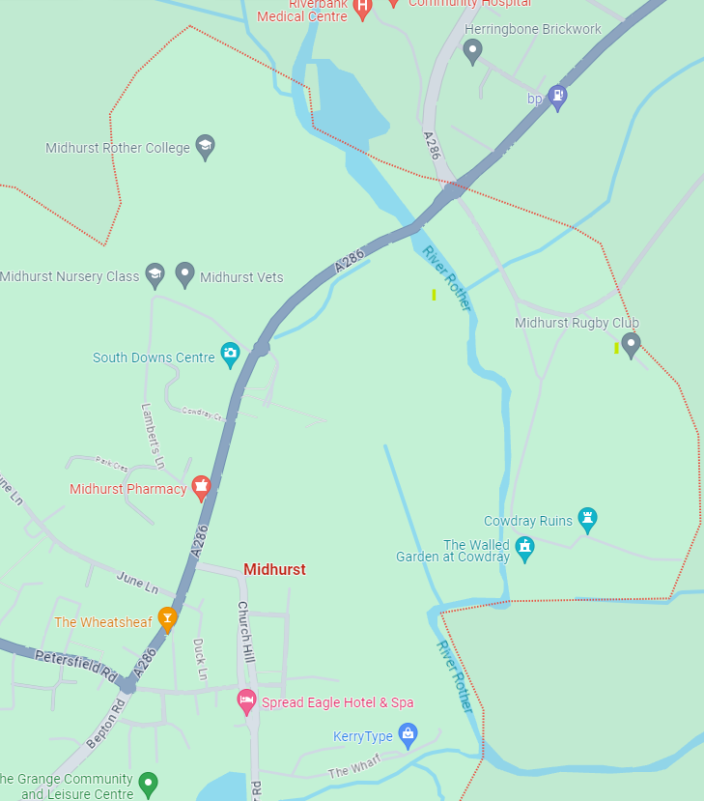
Esso filling station / Post office, Bepton Road
North Street, Midhurst
Rotherfield Pond
See Map Above…. Opening Times 06:00 – 23:00
Tickets MUST be purchased before fishing.
Tickets are NOT sold on the bank and Rother AC waters are bailiffed by the club and the Environment Agency

