CONSTITUTION

The name of the Club shall be THE ROTHER ANGLING CLUB.
The address of the club shall be the Secretary’s address.
The aim of the Club shall be to promote, encourage, and improve facilities for the sport of angling.
Management will be by way of a Committee, consisting of:
- The Chairman
- Club Officers
- Not less than seven other Members

At meetings five shall form a quorum.
The Committee shall have the power to elect Honorary and Life Members and co-opt other Members or alter rules to be effective immediately, but subject to verification at the next AGM.

The Committee shall have the power to discipline in accordance with club procedure any member reported to be in breach of club rules, or of conduct detrimental to the good name of the Club.

The Rother Angling Club and its officers do not accept liability for any injury, loss or damage, however caused.

The Annual General Meeting shall be held between 31st March & 1st of June each year for the purpose of appointing Officers and for transacting any other business.
Any person joining the Club after July 1967, and living outside a ten mile radius of Midhurst can only be accepted as an Associate Member, who, while enjoying full facilities of the Club, may not vote at an AGM or serve on a Committee until three consecutive years of membership have elapsed.

The subscription and entrance fees shall be decided at the AGM and be payable on or before 1st June in any year. Renewal after this date will attract administration fees of £5 in addition to the annual subscription rate .

The Rules of membership of the Club Are:

- Membership permits and EA Rod Licences must be carried at all times, and be produced on demand to the Environment Agency, club bailiffs and club officials.

- Any member who is asked to cease fishing or leave a club water by a Bailiff must do so immediately. All members are invited to check membership of other anglers.

- Any member found to be in breach of any Club rule should be reported in writing to Committee at the Secretary’s address.

- Any breach of Club rules will result in disciplinary action as determined by club disciplinary procedure as laid out in the constitution

- Any member found to be leaving litter will be expelled.

- Any member found to be using behaviour detrimental to the aim of the club will be expelled.

- Use authorised access only to waters, as shown on maps.

- Do not block access to adjoining property, or cause nuisance to our landlords, neighbours or the general public.

- Members may not cut or trim trees, bushes etc to facilitate fishing unless either on authorised working parties or authorised to do so by the comittee.
- No Unauthorised use of Club boats or equipment.

- Tins, cans, dogs, radios, firearms and motorcycles are banned from all Rother AC waters.

- No tackle to be left in the water unattended. In no case should the attending angler be any further than four metres from his/her rods. Rods to be no more than 1 metre apart.

- Pike, eels and trout may be removed from the water. In the case of trout, the necessary EA rod licence must be held. All other fish to be returned to the water alive. No fish to be taken away from any water for use as live or dead bait.

- No junior members are allowed to night fish without the supervision of a senior member (18 years plus) or parent/guardian. Supervised means within two pegs.

- In the interests of safety, no member may fish from North Mill or Woolbeding bridges, or the walls on either side of the sluice at North Mill. No junior members are allowed in the area of the mill pool

- All hooks must be micro-barbed or barbless.

- The Rother Angling Club recommends the use of unhooking mats.

- Members are limited to 2 rods only unless specified in Individual waters’ rules.

- The use of Nut, bean and pulse baits are banned on all Rother A.C. waters

- Pike and trout are excluded from counting in matches

- Matches will only be fished between agreed start and finish times and signals which all competitors are expected to abide by

- During matches, One rod, line and single hook per angler is allowed to be fished at any one time. Other rods maybe made up but not baited and terminal tackle removed from the water

- Spinning, livebaiting and dead baiting are not allowed in matches

- No competitor is allowed to disturb the water prior to the start of matches except to wet groundbaits, plumb the depth or position keepnets.

- No assistance is allowed to play or land fish during matches

- Any competitor still playing a hooked fish at the finish signal will be allowed a period of only 15 minutes after the signal to land the fish.

- 2 nets are required for matches at New Pond and Rotherfield pond. Carp and silver fish must be retained separately.

ROTHER A.C. VENUES
Cooks Pond, Milland Hants : GU30 7JY Lat Long: N51.030248 W0.814791
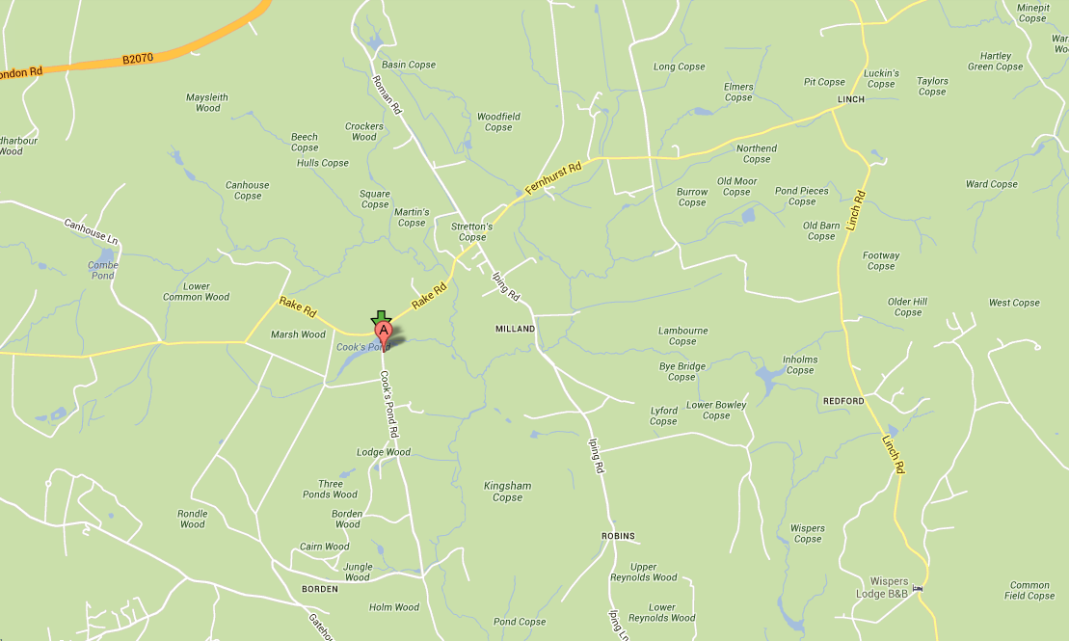
Approximately 4 acres. Parking only on the verge alongside the road. Please park sensibly and do not park opposite driveways . Fishing only from marked pegs. The fishery contains a good head of Crucian Carp, Tench, Roach, Perch Rudd and skimmer bream.
Water closed 1st Feb – 31st April. Strictly NO night fishing

New Pond, Bepton Road, Midhurst : GU29 9RD
Lat Long: N50.980088 W0.751491
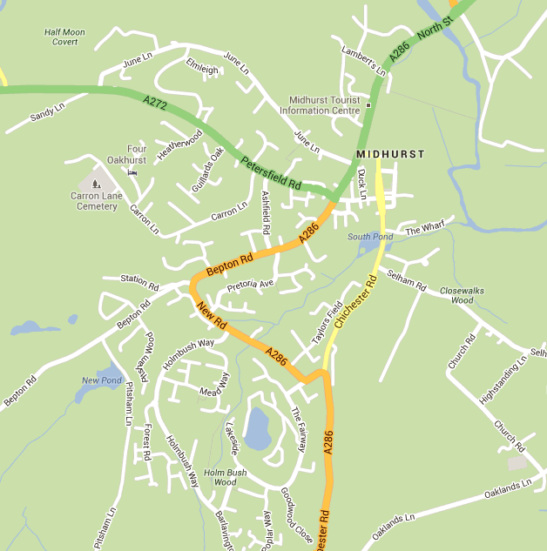
Approximately 2 acres. Parking past the pond on the right, Please park sensibly and leave room for others . Fishing only from marked pegs. The fishery contains a good head of Carp, Roach, Perch Rudd and skimmer bream.
NO floating baits.
Carp may not be retained in nets unless in bona-fide matches.

Rotherfield Pond, Dodsley Lane Easebourne Midhurst West Sussex
GU29 9AW Lat Long: N50.992099 W0.734665
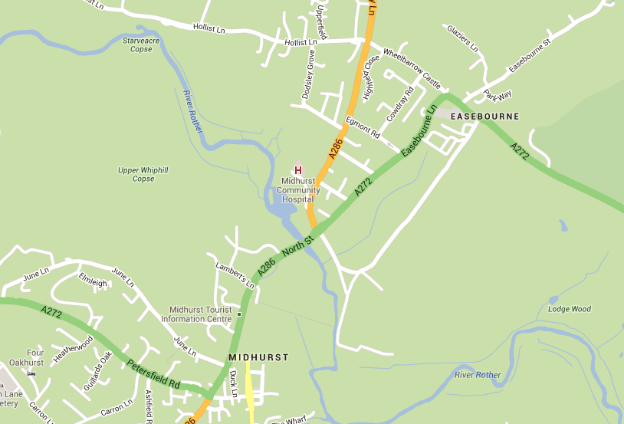
Approximately 1.5 acres. Access adjacent to entrance to Midhurst Community Hospital. (Map) Fishing is from permanent pegs only. Pegs on the north side of the river may also be fished from this point. The fishery contains a good head of Carp, Roach, Perch Rudd Pike Tench and bream.
Carp may not be retained in nets unless in bona-fide matches.

River Rother, North Mill, Dodsley Lane Easebourne Midhurst West Sussex
GU29 9AW Lat Long: N50.992099 W0.734665
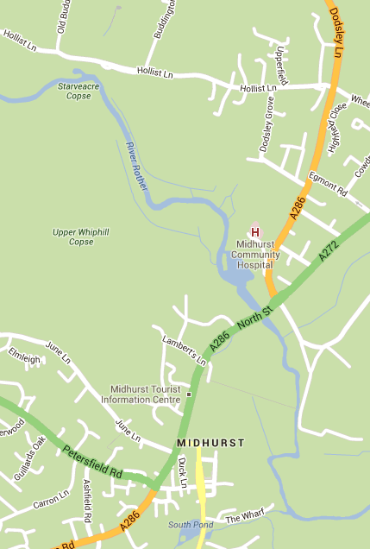
Approximately 3/4 mile of river upstream on North bank, including Mill Pool. Access is from Rotherfield Pond via a path along the North side and behind the medical centre grounds. (Part of the path is steep and can be slippery in wet conditions so please take care) This leads to a wooded area and then into a second field. Fishing from permanent pegs only. The fishery contains Carp, Roach, Dace Grayling Chub Perch Rudd Pike and bream.

River Rother, Woolbeding Midhurst West Sussex
Lat Long: N50.992802 W0.760621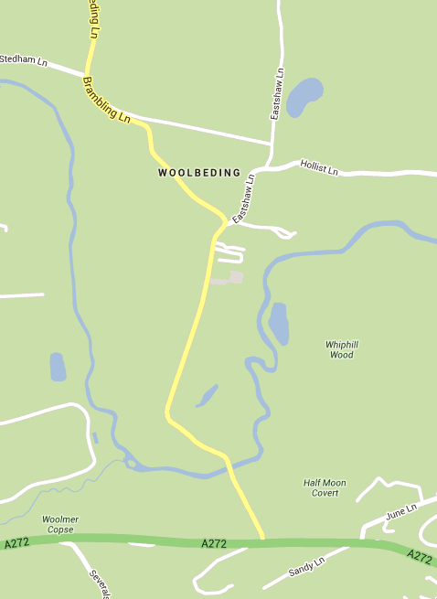
Approximately 1.5 miles upstream from Woolbeding bridge on north bank. Access only via permanant gates. Please keep all gates closed. Parking only on the grass verge on the right after the bend. (opposite the house) DO NOT PARK IN THE GATEWAYS Night fishing is NOT allowed… The fishery contains Roach, Dace Grayling Chub Perch Rudd and Pike.
This fishery is affected by overhead power lines. Exercise caution !!

River Arun, Greatham Bridge Brook Lane, Coldwaltham West Sussex
Lat Long: N50.936499 W0.534799
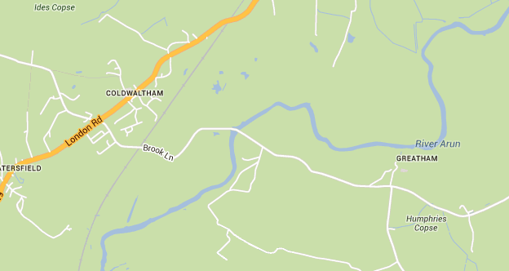
Approximately 0.5 mile west bank upstream of bridge (one field) Parking in car park by bridge only. Access to the upstream stretch is through the metal gate opposite the car park. (These gates must be kept locked at all times. The locks are combination coded and codes are available from pondlife67@googlemail.com on request. ) Access is strictly via the flood bank and river bank only. under no circumstances must members wander onto adjacent land. The fishery contains Carp, Roach, Dace Grayling Chub Perch Rudd Pike eels and bream.

Woolmer Stream: Lat-Long N50.989165,- W0.76664
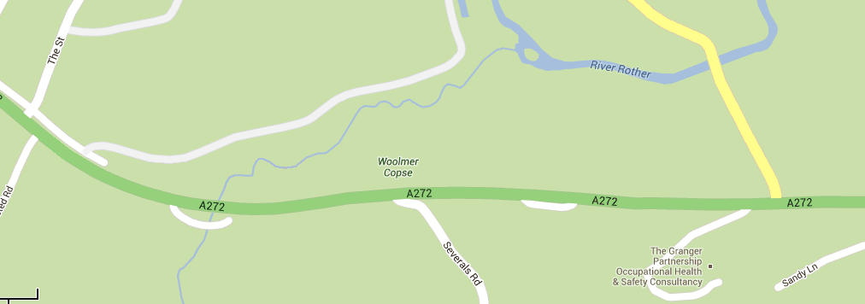
South bank only between bridge on A272 Midhurst – Petersfield Road and junction with River Rother. Parking in layby off A272 (Map) This heavily wooded stream is narrow and shallow with some deep pools and stretches. The fishery contains Roach, Dace Grayling Chub Perch Rudd and Pike.

North Mill Millpool GU29 9AW Lat Long: N50.992099 W0.734665
: 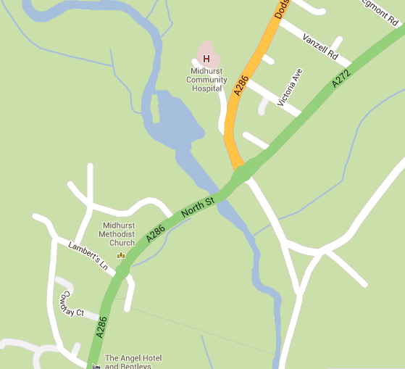
Parking is at Rotherfield Pond, Access via gate on the A272 road bridge, No access to Environment Agency fenced areas No fishing from walls either side of the weir. The fishery contains Roach, Dace Grayling Chub Perch Rudd Bream and Pike.

